WORD 2019

INTERMEDIATE
Please
Select Any
Blue Hyperlinked Text
With Ctrl + Click
For Guidance & Screen Print Examples

Thank You
Within This Book, I Have Decided To Use A Past OCR Advanced Exanimation Guide Within Various Pages, Which I Set Up For Lewisham College, Where I Completed Their Intensive IT Skills Course And Also Supported Them, Back In 2004, Which Is Presented Within This HYPERLINK.

May 2020
September 2018
Presented By
Andrew Stretton

May 2020

Contents Page

CONTENTS PAGE

1. STYLES

5. TEMPLATES & BUILDING BLOCKS

CONTENTS
Title Page

3. FORMATTING TABLES

5.1 Templates

1.1 Examining Formatting

3.1 Table Formatting

5.2 Building Blocks

3.2 Table Styles

1.2 Creating Styles For Hyperlinks

6. GRAPHICS

1.3 Creating Heading Styles

4. MAILINGS

6.1 SmartArt

4.1 Letters

1.4 Creating Numbered & Bulleted Styles

6.2 Formatting SmartArt

4.2 Envelopes With Letters

2. SECTIONS & COLUMNS

7. MANAGING DOCUMENT REVISIONS

4.3 Stand Alone Envelopes

2.1 Creating & Formatting Sections

7.1 Tracking Changes

4.4 Labels

2.2 Working With Columns

7.2 Working With Comments

Top Of Page

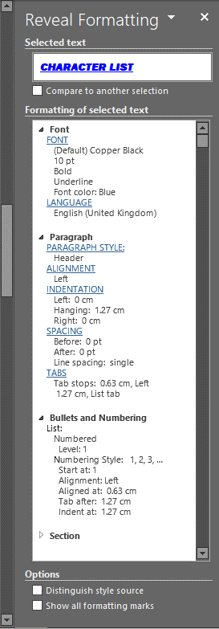
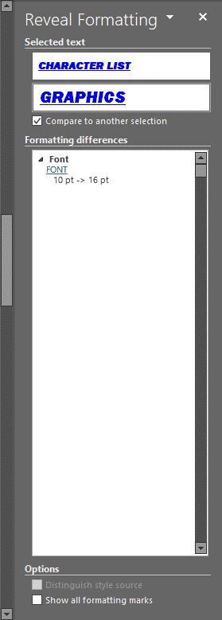

1.1 Examining Formatting
- CHARACTER LIST

  - MATHEMATICAL SYMBOLS
  - SPECIAL CHARACTERS
  - ACCENTS
  - MEASURES

- CHARACTER ATTRIBUTES

  - MATHEMATICAL SYMBOLS
  - SPECIAL CHARACTERS
  - ACCENTS
  - MEASURES

SUBSCRIPT/SUPERSCRIPT
  - BULLETS

- DRAWING ATTRIBUTES

  - TEXT BOXES
  - TEXT BOX SIZES
  - SHADING
  - PAGE BORDERS
  - DIVIDERS

- WRAPPING STYLES

  - SQUARE
  - TIGHT
  - IN FRONT OF TEXT
  - BEHIND TEXT

- PAGE LAYOUTS

- LINE LENGTH
- COLUMNS

- GRAPHICS

- CLIP ART PREPARATION

Title Page
Contents Page
1. STYLES

This Function Is Used To Reveal The Full Details Of Documents Elements, I.E. Fonts, Languages, Paragraph Styles, Etc. This Function Can Also Compare And Re-Format From One To One Or More Using The Reveal Formatting Pane.

- Select Shift & The F1 Function Key, Which Will Bring Up The Reveal Formatting Pane.
- Select Heading 1. CHARACTER LIST, Which Will Now Be Displayed Within The Selected Text Section & All Formatting Details Within The Formatting Of The Selected Text Section.
- Select Compare To Another Selection Check-Box & A Duplicate CHARACTER LIST Will Be Displayed Underneath.
- Select Heading 6. GRAPHICS & The Comparison Font Sizes Are Now Displayed Within The Formatting Differences Section.
- Select The Blue FONT Selection, Which Will Bring Up The Font Dialog Box.
- Select 10 Within Size: Selections, Select OK Button, Which Will Now Make The Content’s Page Heading Fonts Consistent.

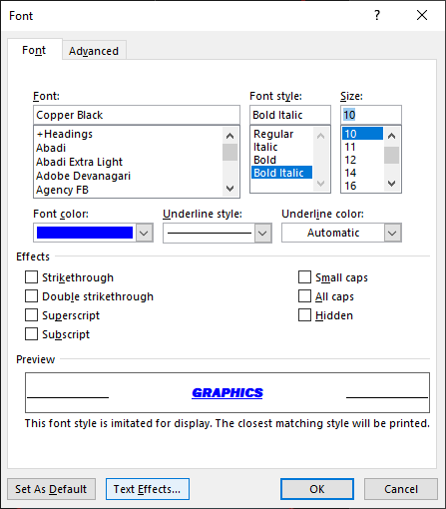

Top Of Page

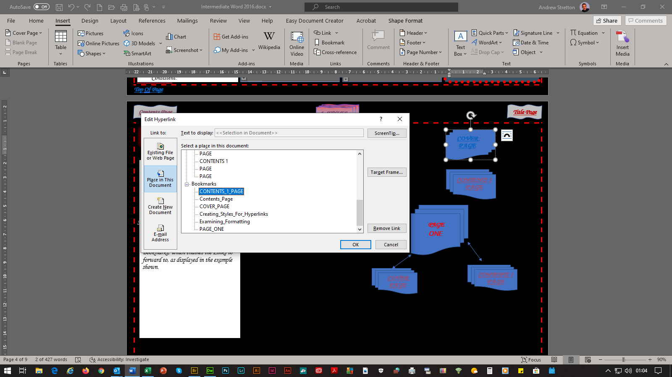
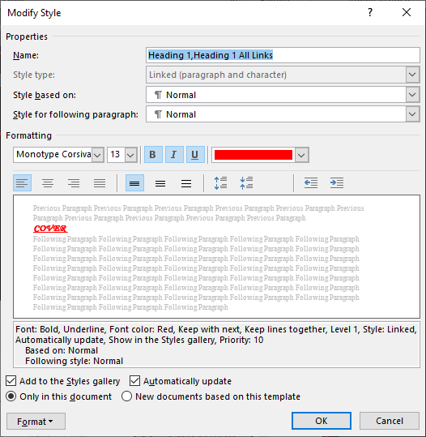

1.2 Creating Styles For Hyperlinks
Title Page
Contents Page
1. STYLES
1. STYLES

COVER

PAGE 1
A Style And Bookmarks Must Be Applied FIRSTLY To Make Hyperlinks Work. The Process Is: 1. Source, 2. Destination, 2. Destination, 1. Source, Forward And Back Making Things Quicker For The Reader(s) To Navigate Rather Than Just Use The Scroll Bar. The Style 1 Selection Is The Most Appropriate Format For This Task.

1. STYLES FOR HYPERLINKS

- Select Text COVER PAGE 1.
- Select Home From The Tab Bar, Select Heading 1 From The Ribbon’s Styles Section, Select The Right Handle Of The Mouse, Select Modify, Which Will Bring Up The Modify Style Dialog Box.
- From The Properties Section: Type A Name For The Style Within The Name: Section, From The Style Based On: Section, Select Normal, From The Style For Following Paragraph: Section, Select Normal.
- Select Automatically Update Check-Box.
- Select Format Button, Select Font, Which Will Bring Up The Font Dialog Box, Select A Font Within The Font: Section, Select Bold Italic Within The Font Style Section: Select A Font Size Within The Size: Section, Select OK Button.

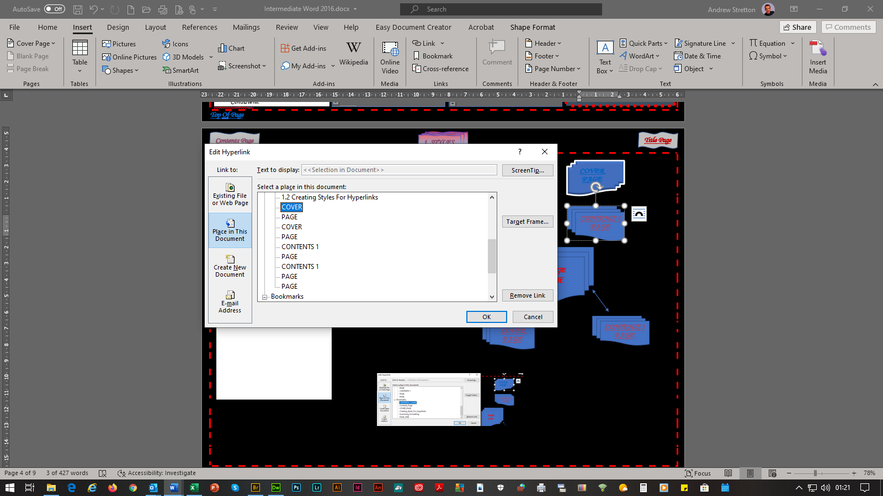

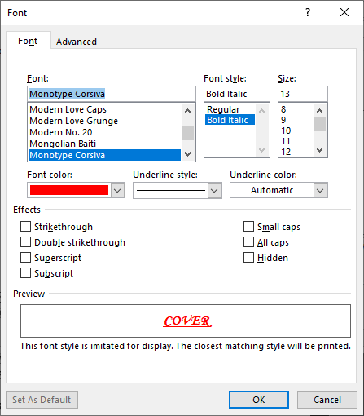
0

CONTENTS

PAGE 1

3. CREATING HYPERLINKS

- Select Text COVER PAGE 1.
- Select Insert From The Tab Bar, Select Link Button, Which Will Bring Up The Insert Hyperlink Dialog Box.
- Scroll Down To Bookmarks Selections & Select CONTENTS_PAGE_1, Select Screen Tip Button, Type COVER PAGE 1, Select OK Button, Select OK Button Again.
- Repeat The Same Procedure, But This Time Select COVER PAGE 1 From The Headings Selections To Return Back To The COVER PAGE 1.

2. CREATING BOOKMARKS

- Select Text CONTENTS PAGE 1.
- Select Insert From The Tab Bar, Select Bookmark Button Within The Links Section, Which Will Bring Up The Bookmark Dialog Box.
- From The Bookmark Name: Section, Type CONTENTS_PAGE_1, Select Add Button.

Top Of Page

MATHEMATICAL SYMBOLS

- Click “Insert” on the “Menu Bar.”
- Click “Symbol.”
- Within the “Symbol Dialog Box” click the “Symbol Font” within the “Font Option.”
It is now possible to assign a “Keyboard Shortcut Key” for each symbol.
- Click the symbol required.
- Click the “Shortcut Key Tab.”
- Press the “Ctrl Key” and a “Numeric Key.”
- Click the “Assign Tab.”
- Click “CLOSE.”
- Click “CLOSE.” Again.

It is now possible to press the “Ctrl Key” and designated “Numeric Key” for the required
symbol.

It is now possible to press the “Ctrl Key” and designated “Numeric Key” for the required symbol.

MATHEMATICAL SYMBOLS
(Symbol Text Option) ± ≥ < > ≈ π ∞ ƒ ∫ √ ≠ Σ ϑ ς ϕ α ψ

SPECIAL CHARACTERS

(Symbol Text Option) ™ © ®

ACCENTS
(Normal Text Option) è é

MEASURES (KEYBOARD ENTERED)

1/4 | & | Spacebar | = | ¼
1/2 | & | Spacebar | = | ½
3/4 | & | Spacebar | = | ¾

SUBSCRIPT/SUPERSCRIPT

- Highlight character.
- Click the “Right Handle” of the “Mouse.”
- Click “Font.”
- Within the “Font Dialog Box”
click “Subscript” or “Superscript.”
- Click “OK.”

BULLETS

- Highlight text.
- Click the “Right Handle” of the “Mouse.”
- Click “Bullets and Numbering.”
- Within the “Bullets and Numbering Dialog Box”
click the “Bulleted Tab.”
- Click the desired bullet.
- Click “OK.”

1.3 Creating Heading Styles
Title Page
Contents Page
1. STYLES
Title Page

When You Create A Style, You Can Use It Throughout Your Whole Document, Applying Formatting Within Sections, I.E. Headings, Subheadings, Paragraphs, Numbered Lists, Bulleted Lists, Borders, Etc (Graphics Excluded) Which Can Be Saved, Modified And Updated Automictically.

HEADINGS STYLES

- Select Heading MATHEMATICAL SYMBOLS.
- Select Home From The Tab Bar, Select Normal Style From The Ribbon’s Styles Section, Select The Styles Dialog Box Launcher, Which Will Bring Up The Styles Dialog Box, Select New Style Button, Which Will Bring Up The Create New Style From Formatting Dialog Box.
- From The Properties Section: Type 3. MAIN PAGE HEADINGS Within The Name: Section, Select Linked (Paragraph And Character) Within The Style Type: Section, Select 3. MAIN PAGE HEADINGS Within The Style Based On: Section, Select Normal For Style For Following Paragraph: Section.
- Select Automatically Update Check-Box.
- Select Format Button, Select Font, Which Will Bring Up The Font Dialog Box, Select A Font Within The Font: Section, Select Bold Italic Within The Font Style Section: Select A Font Size Within The Size: Section, Select A Font Color within the Font Color Selections, Select OK Button.
- Select Format Button, Select Paragraph, Which Will Bring Up The Paragraph Dialog Box.
- Within The Spacing Section, Type 7 pt Within After Selections, Select OK Button, Select OK Button Again.
- Select Heading MATHEMATICAL SYMBOLS.
- Select Right Handle Of The Mouse Whilst Over The 3. MAIN HEADINGS PAGE Style Box Selection, Select, Select All 7 Instance(s), Which Will Highlight All Headed Styles, In Which You Can Modify Or Apply A New Style On A Style.

Top Of Page

- CHARACTER LIST

  - MATHEMATICAL SYMBOLS
  - SPECIAL CHARACTERS
  - ACCENTS
  - MEASURES

- CHARACTER ATTRIBUTES

  - MATHEMATICAL SYMBOLS
  - SPECIAL CHARACTERS
  - ACCENTS
  - MEASURES
  - SUBSCRIPT/SUPERSCRIPT
  - BULLETS

- DRAWING ATTRIBUTES

  - TEXT BOXES
  - TEXT BOX SIZES
  - SHADING
  - PAGE BORDERS
  - DIVIDERS

- WRAPPING STYLES

  - SQUARE
  - TIGHT
  - IN FRONT OF TEXT
  - BEHIND TEXT

- PAGE LAYOUTS

  - LINE LENGTH
  - COLUMNS

- GRAPHICS

  - CLIP ART PREPARATION

1.4 Creating Numbered & Bulleted Styles
Title Page
Contents Page
1. STYLES

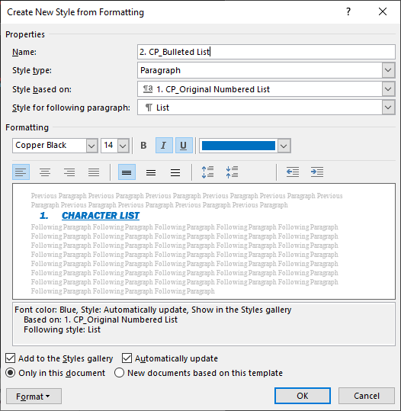
NUMBERED & BULLETED LIST STYLES

- Select Heading 1. Character List,
- Select Home From The Tab Bar, Select Normal Style From The Ribbon’s Styles Section, Select The Styles Dialog Box Launcher, Which Will Bring Up The Styles Dialog Box, Select New Style Button, Which Will Bring Up The Create New Style From Formatting Dialog Box.
- From The Properties Section: Type 2. CP_Bulleted List Within The Name: Section, Select Paragraph From The Style Type: Section, Select 1. CP_Original Numbered List From The Style Based On: Section, Select List From The Style For Following Paragraph: Section.
- Select The Color Selections Choices Drop Down List & Change Light Blue To Blue.
- Select Automatically Update Check-Box.
- Select Format Button, Select Numbering Selection, Which Will Bring Up The Numbering And Bullets Dialog Box, Select Bullets Tab, Select OK Button, Select OK Button Again.
- Using The Ruler Adjust The Bullets Alignments.
- Select Heading 1. Character List,
- Select Right Handle Of The Mouse Whilst Over The 1. Cp Original Numbered List Style Box Selection, Select, Select All 6 Instance(s), Select CP_Bulleted List, Which Will Reflect This Style & By Hovering The Mouse Pointer Over Each Will Switch Style Formats.

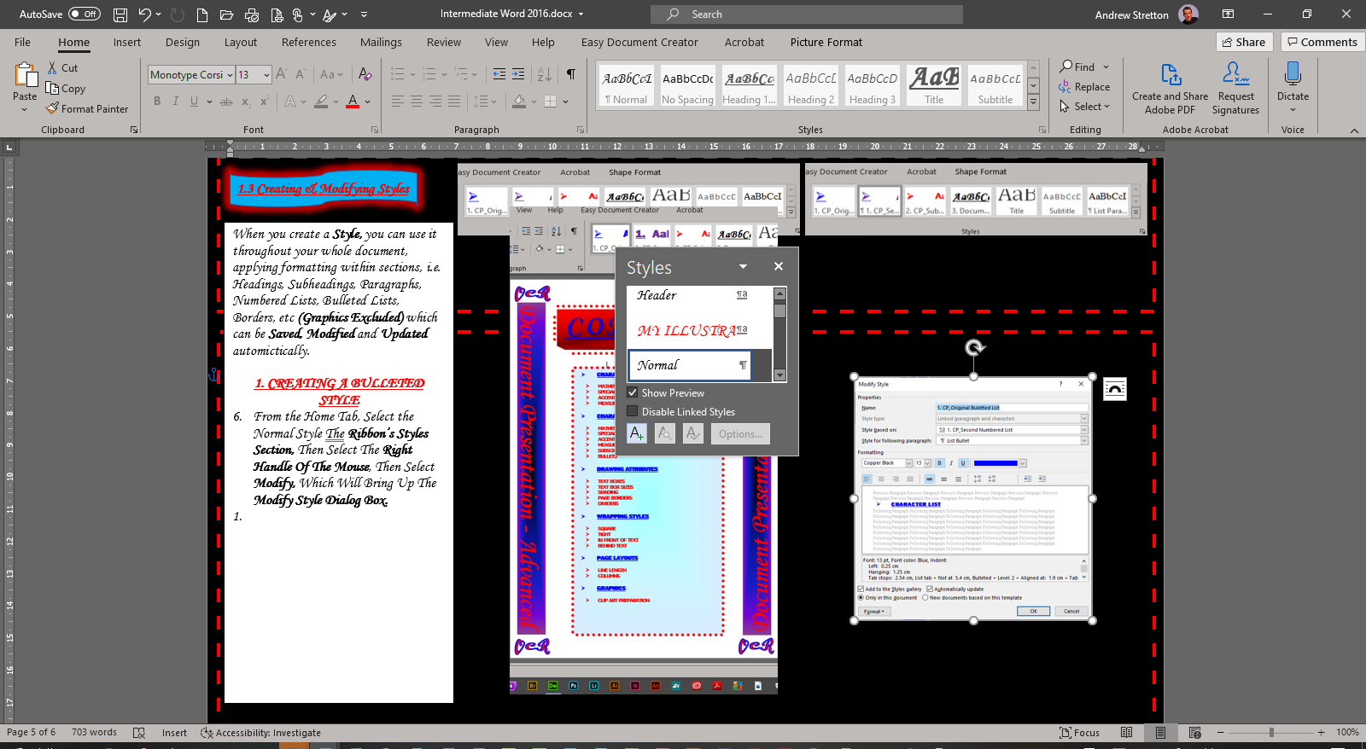

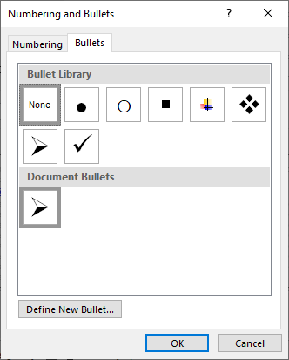

Top Of Page

1.4 Outlining
1. STYLES
TEXT

Top Of Page

2.1 Creating & Formatting Sections

2. SECTIONS & COLUMNS COLUMNS

Title Page
Contents Page


SECTION BREAKS

Section Breaks Allow For Headers & Footers Details To Be Displayed Differently Within Each Page, As With Page Breaks These Actions Cannot Be Integrated. It Also Allows For Pages Of The Document To Be Formatted As Portrait And Landscape As Adjacent Pages, Different Margins Settings To Accommodate For A Graphic, Etc. Also, It Allows For Page Numbers To Be Inserted And Started At Different Pages, I.E. Page Three, Page Four, Page Five, Etc Can Start As Page Number 1, 2, 3, Etc.

1. NEXT PAGE SECTION BREAKS

2. LANDSCAPE PAGE LAYOUT

3. UN-LINKED HEADERS

4. UN-LINKED PAGE NUMBERS

SELECT LINK FOR EXAMPLE

Top Of Page

RACE DAY
CLASSES TO RACE

If there are 5 or more entries in any class for which a separate race has not been organised, then they will start with the most suitable handicap class and will be treated as a separate class for results and prizes.

If a yacht does not have such a number, the committee will use the formulae (D ÷ 2240) ÷ (0.01 x L)³ and S ÷ (D ÷ 64)^{2/3} to compare the performance if different yachts, where D is displacement, L is load waterline and S is sail area.

CONDITIONS OF ENTRY

The race organisers shall not be liable for any loss, damage, death, or personal injury howsoever caused to the owner and crew, as a result of their taking part in the race or races. Moreover, every owner warrants the suitability of his yacht for the race or races, and the suitability and adequacy of his insurance cover.

Safety equipment must be properly maintained, stowed and in date and the competition must know where it is kept and how to use it.

RACE ENTRY FORM AND FEES

Entries to race shall be by the completion of the regatta race entry form, the payment of the appropriate fee and their acceptance by the race organising committee. A separate entry form must be submitted for each yacht.

POSTPONED OR ABANDONED RACES

Races postponed will not be re-scheduled, neither will race fees be refunded.

SAILING INSTRUCTIONS

Race instructions will be issued from the committee room from 1200 hours on Friday 1 August onwards. Courses will also be displayed on a board outside the yacht club at least 2 hours outlined below will be used.

2.2 Working With Columns

2. SECTIONS & COLUMNS COLUMNS

Contents Page
Title Page

Columns Are Used For The Separation Of Paragraphs, Which Are Adjoined By Two Columns Or More. They Can Also Adjoin Long Numbered Lists, Which Do Not Necessarily Need To Run Onto The Next Page, Converting Them Into A Two Column One Page List.

COLUMNS

- Position Cursor To The End Of Heading RACE DAY.
- Select Layout From The Tab Bar.
- Select Breaks Button Within The Ribbon’s Page Setup Section.
- Scroll Down, Select Continuous Within The Section Breaks Section.
- Select Sub-Heading CLASSES TO RACE & All Headings & Paragraphs After.
- Select Layout From The Tab Bar.
- Select Columns Button Within The Ribbon’s Page Setup Section.
- Scroll Down, Select More Columns Button, Which Will Bring Up The Columns Dialog Box.
- Select Two Column Button Within The Presets Section.
- Select OK Button.

SELECT LINK FOR
NEXT PAGE’S LAYOUT

Top Of Page

2. SECTIONS & COLUMNS COLUMNS

Contents Page
Title Page
Title Page
RACE DAY

CLASSES TO RACE

If there are 5 or more entries in any class for which a separate race has not been organised, then they will start with the most suitable handicap class and will be treated as a separate class for results and prizes.

If a yacht does not have such a number, the committee will use the formulae (D ÷ 2240) ÷ (0.01 x L)³ and S ÷ (D ÷ 64)^{2/3} to compare the performance if different yachts, where D is displacement, L is load waterline and S is sail area.

CONDITIONS OF ENTRY

The race organisers shall not be liable for any loss, damage, death, or personal injury howsoever caused to the owner and crew, as a result of their taking part in the race or races. Moreover, every owner warrants the suitability of his yacht for the race or races, and the suitability and adequacy of his insurance cover.

Safety equipment must be properly maintained, stowed and in date and the competition must know where it is kept and how to use it.

Top Of Page

RACE ENTRY FORM AND FEES

Entries to race shall be by the completion of the regatta race entry form, the payment of the appropriate fee and their acceptance by the race organising committee. A separate entry form must be submitted for each yacht.

POSTPONEDOR ABANDONED RACES

Races postponed will not be re-scheduled, neither will race fees be refunded.

SAILING INSTRUCTIONS

Race instructions will be issued from the committee room from 1200 hours on Friday 1 August onwards. Courses will also be displayed on a board outside the yacht club at least 2 hours outlined below will be used.

Contents Page
Tables Allow Text And Numbers To Be Kept Organised Into Rows And Columns. They Allow For Various Formatting From The Tab Bar’s Layout Functions, Such As: Text Alignments, Direction, Height, Width, Auto Fit, Add And Delete Rows/Columns, Etc. The Table Design Functions Also Vary, Such As: Borders, Shading, Tables Styles, Etc. They Also Allow For Preset Tables To Be Used As I Have Below Once I Set Up Standard Table, I Then Applied This Preset Below From The Table Styles Gallery Within The Table Design Tab’s, Table Styles Gallery For The Shading.

3.1 Table Formatting

3. FORMATTING TABLES
Title Page

TABLE FORMATTING

- Select View From The Tab Bar.
- Select Ruler Check-Box Within The Ribbon’s Show Section.
- Select Insert From The Tab Bar.
- Select Table Button Drop Down List Within The Ribbon’s Tables Section.
- Select 4 Columns, 8 Rows Within The Insert Table Selections.
- Type Headings.
- Select Left Column.
- Select Layout From The Tab Bar.
- Select Insert Left Button Within The Ribbon’s Rows & Columns Section.
- Select Merge Cells Button Within The Ribbon’s Merge Section.
- Type Heading.
- Select Text Direction Button Within The Ribbon’s Alignment Section.
- Adjust Font Size To 18 Pt.
- Select All Adjacent Rows.
- Select Height Selections Within The Ribbon’s Cell Size Section.
- Adjust To 0.9 cm.
- Selection Final Row.
- Adjust To 0.2 cm.
- Select All Rows.
- Select Table Design From The Tab Bar.
- Select Grid Table 5 Dark - Accent 1 Within The Ribbon’s Table Styles Gallery.
- Select Layout From The Tab Bar.
- Select Align Center Left Button Within The Ribbon’s Alignment Section.
- Select Table Design From The Tab Bar.
- Select First Bottom Cell.
- Select Shading Button, Which Will Apply No Shading Automatically.
- Repeat This Procedure For Cells 3 & 4.
- Select All Column Headings.
- Select Home From The Tab Bar.
- Select Bold, Underlined & Center Within The Ribbon’s Font & Paragraph Sections.

Table Style Preset – Grid Table 5 – Dark Accent 1 - Implemented On My Own Inserted Table

MY PRESENT COURSES | COURSE | COST | START | STATUS
MY PRESENT COURSES | Advanced Photoshop 2018 To 2020 | £150.00 | Feb 2019 | Good
MY PRESENT COURSES | Advanced Illustrator 2018 To 2020 | £150.00 | May 2019 | Good
MY PRESENT COURSES | Advanced PowerPoint 2019 | £85.00 | Feb 2020 | Complete
MY PRESENT COURSES | Intermediate Word 2019 | £70.00 | May 2020 | Good
MY PRESENT COURSES | Intermediate Excel 2019 | £70.00 | June 2020 | To Start
MY PRESENT COURSES | Advanced Outlook 2019 | £70.00 | July 2020 | To Start
MY PRESENT COURSES |  | £ 595.00

- Select Second Bottom Cell.
- Select Layout From The Tab Bar.
- Select Fx Formula Button Within The Ribbon’s Data Section, Which Will Bring Up The Formula Dialog Box.
- Within The Formula: Section, Select The Default =SUM(ABOVE)
- Within The Number Format: Section, Scroll Down, Select £#,##0.00;(£#,##0.00)
- Select OK Button.
- Select All Cells Under COST.
- Select A Decimal Tab From The Ruler’s Top Left Tab Button Selections.
- Align Decimal Points Accordingly.
- Select Whole Table.
- Select Layout From The Tab Bar.
- Select AutoFit Button Within The Ribbon’s Cell Size Section
- Select AutoFit Window.

Top Of Page

Contents Page

3. FORMATTING TABLES
Title Page

3.2 Table Styles

MY PRESENT COURSES | COURSE | COST | START | STATUS
MY PRESENT COURSES | Advanced Photoshop 2018 To 2020 | £150.00 | Feb 2019 | Good
MY PRESENT COURSES | Advanced Illustrator 2018 To 2020 | £150.00 | May 2019 | Good
MY PRESENT COURSES | Advanced PowerPoint 2019 | £85.00 | Feb 2020 | Complete
MY PRESENT COURSES | Intermediate Word 2019 | £70.00 | May 2020 | Good
MY PRESENT COURSES | Intermediate Excel 2019 | £70.00 | June 2020 | To Start
MY PRESENT COURSES | Advanced Outlook 2019 | £70.00 | July 2020 | To Start
MY PRESENT COURSES |  | £ 595.00

Original Table Style Preset List Table 7 Colorful
TABLE STYLES

Table Styles Allow Formatting To Be Applied To A Table Style That You Have Saved Within The Custom Section Of The Table Styles Gallery, Which You Can Use On Any Other Table That You Have Created.
APPLYING A PRESET TABLE STYLE

- Select ROW 1 OF TABLE 1.
- Select Table Design From The Tab Bar.
- Select List Table 7 Colorful Within The Table Styles Gallery.

CREATING A TABLE STYLE ON A PRESET STYLE

- Select Row 1 Of Table 1.
- Select Table Design From The Tab Bar.
- Select List Table 7 Colorful Within The Table Styles Gallery.
- Select The Right Handle Of The Mouse.
- Select New Table Style, Which Will Bring Up The Create New Style From Formatting Dialog Box.
- From The Properties Section: Type MY STYLE Within The Name: Section, Select Table From Style Type: Section, Select List Table 7 Colorful Within The Style Based On: Section.
- Select OK Button.
- MY STYLE Table Will Now Be Saved Within The Custom Styles Selections.

MODIFYING A TABLE STYLE

- Select Row 1 Of Table 2.
- Select Table Design From The Tab Bar.
- Select Right Handle Of The Mouse, Whilst Over MY STYLE Preset.
- Select Modify Table Style, Which Will Bring Up The Modify Style Dialog Box.
- From The Apply Formatting To Selections, Select Header Row.
- From The Fill Color Selections, Select Light Blue.
- Select OK Button.
- Select OK Button.
- Select Row 1 Of Table 1, Then Apply MY STYLE.

MY PRESENT COURSES | COURSE | COST | START | STATUS
MY PRESENT COURSES | Advanced Photoshop 2018 To 2020 | £150.00 | Feb 2019 | Good
MY PRESENT COURSES | Advanced Illustrator 2018 To 2020 | £150.00 | May 2019 | Good
MY PRESENT COURSES | Advanced PowerPoint 2019 | £85.00 | Feb 2020 | Complete
MY PRESENT COURSES | Intermediate Word 2019 | £70.00 | May 2020 | Good
MY PRESENT COURSES | Intermediate Excel 2019 | £70.00 | June 2020 | To Start
MY PRESENT COURSES | Advanced Outlook 2019 | £70.00 | July 2020 | To Start
MY PRESENT COURSES |  | £ 595.00

“MY STYLE” OWN PRESET

Top Of Page

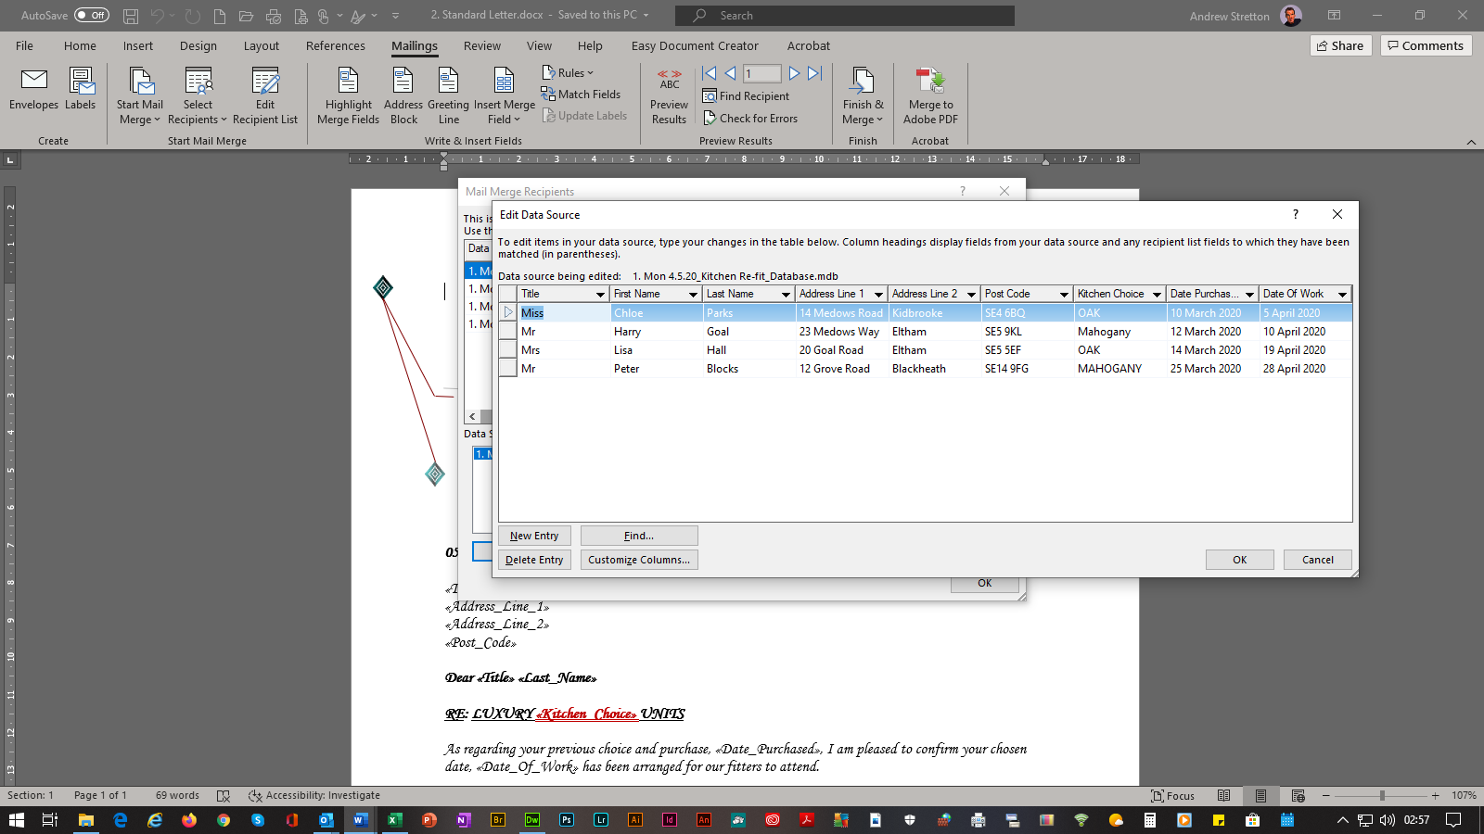
Contents Page
Title Page

4.1 Letters

4. MAILINGS

Mailings Are Storage Of Companies And People’s Details, Which Companies Store For Various Reasons, Depending On How Their Businesses Operate On A Day To Day Basis And They All Need To Send Out Correspondence, Which Contains The Recipients’ Names And Addresses, But Also With Further Details, Such As Billing Information, Dates, Times, Etc, Which Are Merged Individually And Are Stored Within Databases. Word Uses The Access Database. Excel And Outlook Can Also Be Used For This Task.

1. DATABASE

- Select Mailings From The Tab Bar.
- Select, Select Recipients’ Button Within The Ribbon’s Start Mail Merge Section.
- Select Type A New List, Which Will Bring Up The New Address List Table.
- Enter Each Recipient’s Details.
- Select Customize Columns Button.
- Select Delete Button To Clear Any Un-Wanted Default Fields.
- Select Add Button For Kitchen Choice, Date Purchased & Date Of Work Fields.
- Select OK Button.
- Select OK Button.
- Select OK Button Again.
- Save Database As: 1. Mon 4.5.20_Kitchen Re-Fit_Database

2. STANDARD LETTER

- From A Company Headed Letter.
- Position Cursor After Present Date.
- Select Mailings From The Tab Bar.
- Select, Select Recipients’ Button Within The Ribbon’s Start Mail Merge Section.
- Select Use An Existing List, Which Will Bring Up The Select Data Source Window.
- Select Database: 1. Mon 4.5.20_Kitchen Re-Fit_Database
- Select Insert Merge Field From The Drop Down Selections Within The Ribbon’s Write & Insert Fields Section.
- Continue Throughout Each Section Of The Letter, Which Requires Each Field At The Relevant Point(s).
- Save Standard Letter As: 2. Standard Letter

3. MERGED LETTERS

- Select Finish & Merge Drop Down Button Within The Ribbon’s Finish Section.
- Select Edit Individual Documents Selection, Which Will Now Merge The Four Customers’ Names/Addresses, Kitchen Cabinets Choices, Date Of Choice & Date Of Fitting Into All Designated Points.
- Save Merged Documents As: 2A. Merged Letters

N.B. The Browser’s File “Keep” & “Disregard” Warning Dialog Box Will Appear, Select Keep Button, Then Select Open Button To The Open File – Security Warning Dialog Box Message.

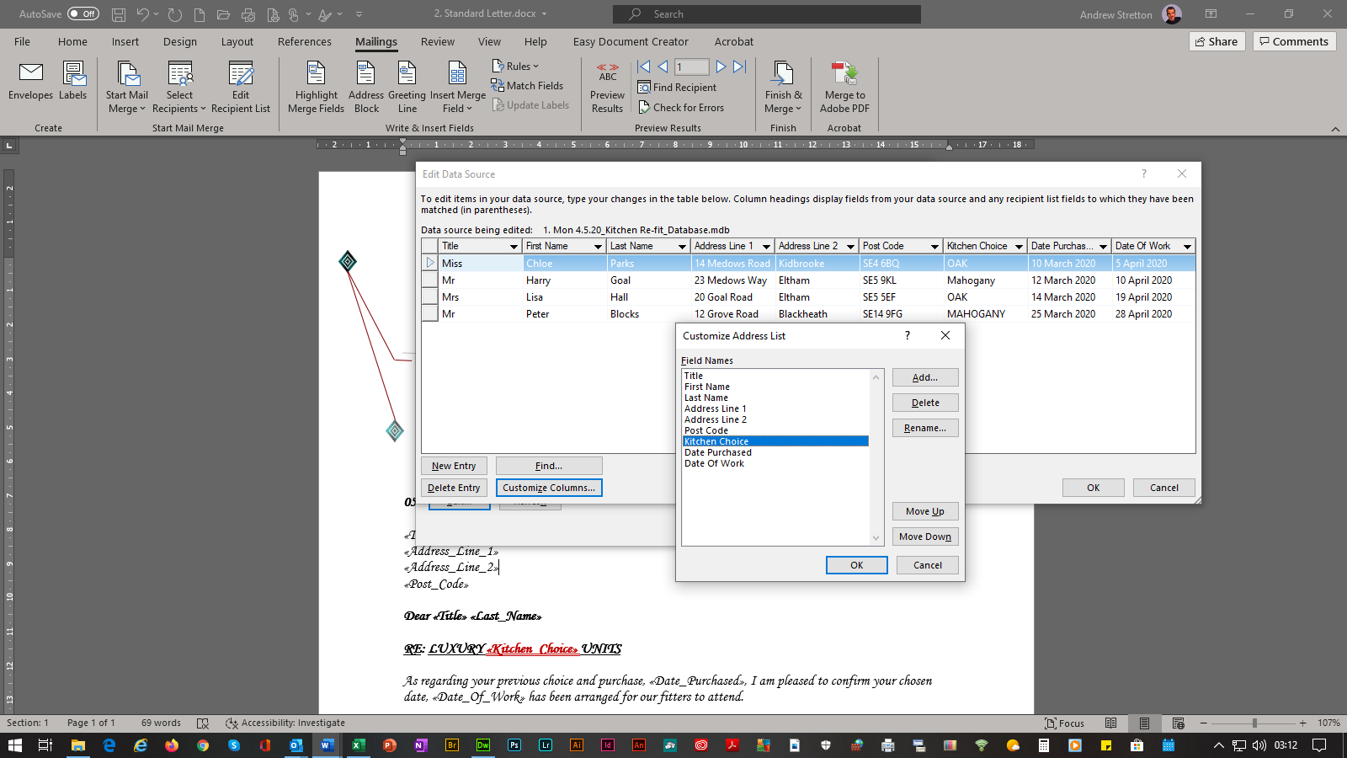
0

N.B. The Microsoft Word SQL Command: Dialog Box Link To Database Details Will Appear After Download Confirmation, Select Yes Button.

Top Of Page

Contents Page

4.2 Envelopes With Letters

4. MAILINGS

Title Page

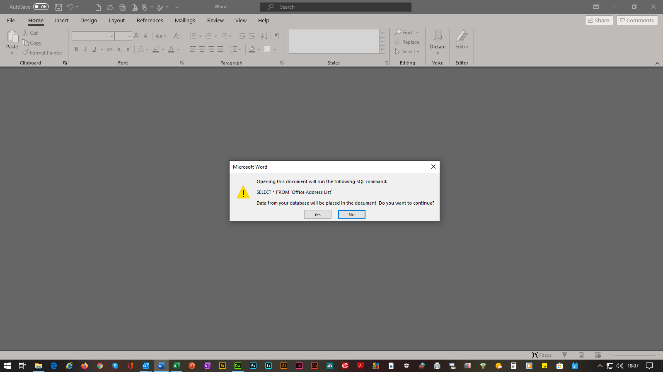
Envelops Are Merged In The Same Way As Letters Via The Database, Which The Addresses Are Stored Within. You Can Either Merge Envelopes With All The Letters As Below, As A Single File Or Separately As I Have Included Within The Next Page 4.3 Stand Alone Envelopes.
1. STANDARD ENVELOPE WITH LETTER

- Select: 2. Standard Letter, Which Will Bring Up The Microsoft Word SQL Command: Dialog Box.
- Select No Button, As The Previously Stored Database Names/Addresses Will Be Implemented Later.
- Select Mailings From The Tab Bar.
- Select, Envelopes Button Within The Ribbon’s Create Section, Which Will Bring Up The
Envelopes And Labels Dialog Box.
- Select Options Button, Which Will Bring Up The Envelope Options Dialog Box.
- Select Your Size Of Envelope Within The Envelope Size: Section.
- Select OK Button.
- Select Add To Document Button, Which Will Insert A Blank Envelope With A Placeholder Above The Second Page Company Headed Letter.
- Select The Placeholder, Positioning The Cursor For The First Fields & Positioning It Accordingly To Print Layout.
- Select Select Recipients’ Button Within The Ribbon’s Start Mail Merge Section.
- Select Use An Existing List, Which Will Bring Up The Select Data Source Window.
- Select Database: 1. Mon 4.5.20_Kitchen Re-Fit_Database.mdb
- Select Open Button.
- Select Insert Merge Field From The Drop Down Selections Within The Ribbon’s Write & Insert Fields Section.
- Continue Throughout Each Section Of The Envelope, Which Requires Each Field At The Relevant Point(s).
- Select Preview Results Button Within The Ribbon’s Preview Results Section, Which will Display The First Database Name/Address.
- Select File From The Tab Bar.
- Select Print, Which will bring up the Print Window Dialog Box Functions & Print Preview.
- Return Back To Print Layout.
- Select File From The Tab Bar.
- Save 2. Standard Letter As: 3. Standard Envelope With Letter

2. MERGED ENVELOPES WITH LETTERS & PRINTING INSTRUCTIONS

- Select Finish & Merge Drop Down Button Within The Ribbon’s Finish Section.
- Select Edit Individual Documents Selection, Which Will Now Merge The Four Customers’ Names/Addresses Into Their Envelopes, Along With Kitchen Cabinets Choices, Date Of Choice & Date Of Fitting Into All Designated Points.
- Save Merged Documents As: 3A. Merged Envelopes With Letters

N.B. The Microsoft Word SQL Command: Dialog Box Link To Database Details Will Appear After Download Confirmation, Select Yes Button.

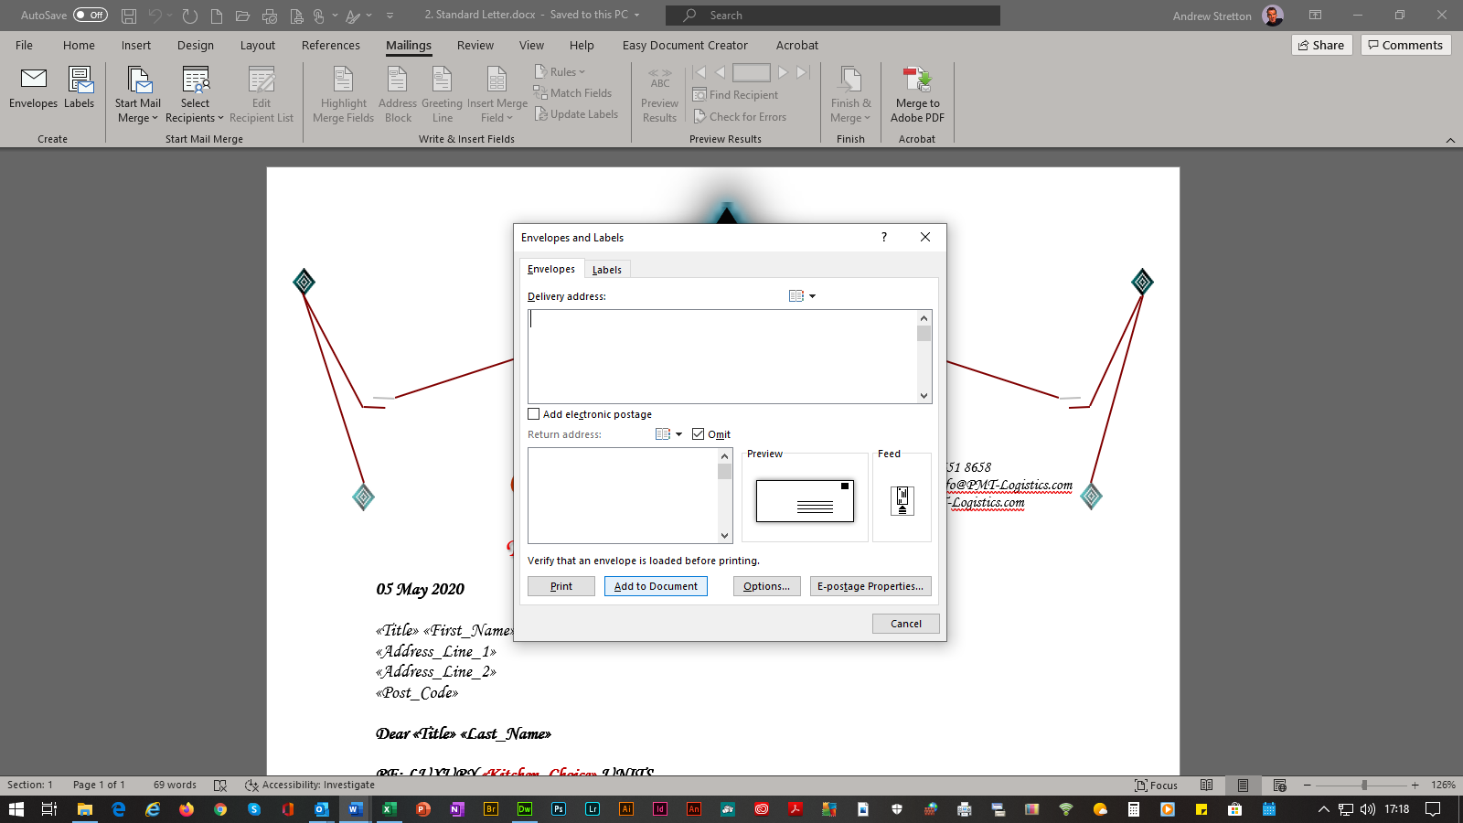

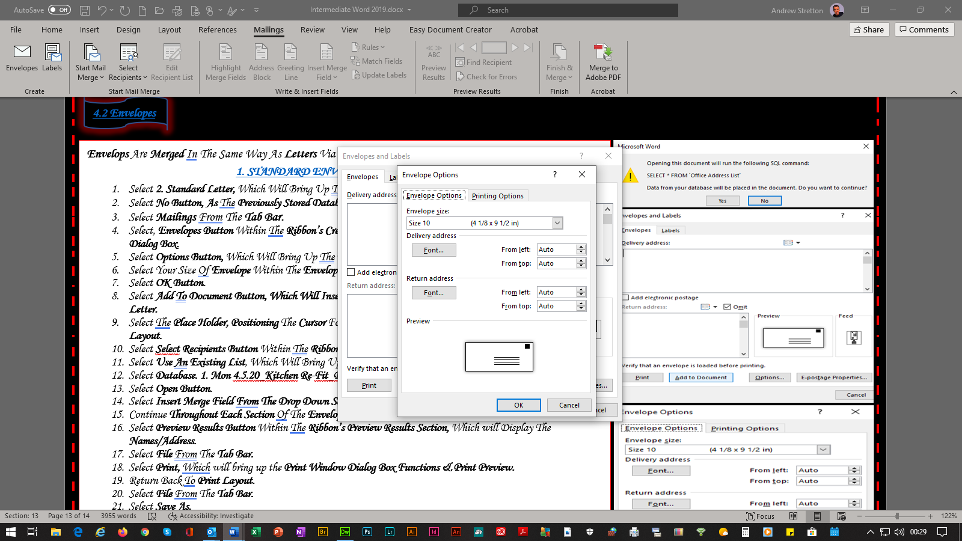

Top Of Page

Contents Page

4.3 Stand Alone-Envelopes

4. MAILINGS

Title Page

1. STANDARD STAND-ALONE ENVELOPES
- Open Word.
- Select A New Blank Document.
- Select Mailings From The Tab Bar.
- Select Paragraph Marks Button Within The Ribbon’s Paragraph Section, As You Will Need To Make Page Breaks Later.
- Select Mailings From The Tab Bar.
- Select Envelopes Button Within The Ribbon’s Create Section, Which Will Bring Up The Envelopes And Labels Dialog Box.
- Select Options Button, Which Will Bring Up The Envelopes Options Dialog Box.
- Select Your Size Of Envelope Within The Envelope Size: Section.
- Select OK Button.
- Select Add To Document Button, Which Will Insert A Blank Envelope With A Placeholder Above The Second Blank Page.
- Select Select Recipients’ Button Within The Ribbon’s Start Mail Merge Section.
- Select Use An Existing List, Which Will Bring Up The Select Data Source Window.
- Select Database: 1. Mon 4.5.20_Kitchen Re-Fit_Database.mdb
- Select Open Button.
- Select Insert Merge Field From The Drop Down Selections Within The Ribbon’s Write & Insert Fields Section.
- Continue Throughout Each Section Of The Envelope, Which Requires Each Field At The Relevant Point(s).
- Enter A Return Key After «Post_Code» Field.
- Select Rules Button Drop Down List Within The Write & Insert Fields Section.
- Select «Next Record»
- Position Cursor Directly On The Revealed First Section Break _______________ (Next Section) _______________
- Select Ctrl Key, Then Enter Key For The Required Amount Of Page Breaks And The Required Amount Of Envelopes.
- Scroll Back To The First Page Envelope & Select Placeholder.
- Select Copy From The Home Tab’s Clipboard Section.
- Position Cursor Directly On The Revealed Second Page Break _______________ (Page Break) _______________
- Select Paste From The Home Tab’s Clipboard Section.
- Continue This Procedure For All Other Envelopes.
- Select Preview Results Button Within The Ribbon’s Preview Results Section, Which will Display The Names/Addresses.
- Save Word Document As: 4. Standard Stand-Alone Envelopes

2. MERGED STAND-ALONE ENVELOPES

- Select Finish & Merge Drop Down Button Within The Ribbon’s Finish Section.
- Select Edit Individual Documents Selection, Which Will Now Merge The Four Customers’ Names/Addresses Into Each Envelope.
- Save Merged Envelopes As: 4A. Merged Stand-Alone Envelopes

N.B. The Microsoft Word SQL Command: Dialog Box Link To Database Details Will Appear After Download Confirmation, Select Yes Button.

Top Of Page

Contents Page
Title Page

4.4 Labels

4. MAILINGS

Labels Are Merged In The Same Way As Letters And Envelopes Via The Database, Which The Addresses Are Stored Within.

1. STANDARD LABELS

- Open Word.
- Select A New Blank Document.
- Select Mailings From The Tab Bar.
- Select Labels Button Within The Ribbon’s Create Section, Which Will Bring Up The Envelopes And Labels Dialog Box.
- Select Options Button, Which Will Bring Up The Labels Options Dialog Box.
- Select Your Size Of Labels Within The Product Number: Section.
- Select OK Button.
- Select New Document Button, Which Will Insert A Gridline Table.
- Select Mailings From The Tab Bar.
- Select Select Recipients’ Button Within The Ribbon’s Start Mail Merge Section.
- Select Use An Existing List, Which Will Bring Up The Select Data Source Window.
- Select Database: 1. Mon 4.5.20_Kitchen Re-Fit_Database.mdb
- Select Open Button.
- Select Insert Merge Field From The Drop Down Selections Within The Ribbon’s Write & Insert Fields Section.
- Continue Throughout The First Top Left Cell Only, Which Requires Each Field At The Relevant Point(s).
- Enter A Return Key After «Post_Code» Field.
- Select Rules Button Drop Down List Within The Write & Insert Fields Section.
- Select «Next Record»
- Select All Fields Within This Cell.
- Select Copy From The Home Tab’s Clipboard Section.
- Select Second Top Left Cell.
- Select Paste From The Home Tab’s Clipboard Section.
- Continue This Procedure For Every Cell, As More Addresses Can Be Added To The Database For Future Uses.
- Select Preview Results Button Within The Ribbon’s Preview Results Section, Which will Display The Names/Addresses.
- Save Standard Label As: 5. Standard Labels
2. MERGED LABELS

- Select Finish & Merge Drop Down Button Within The Ribbon’s Finish Section.
- Select Edit Individual Documents Selection, Which Will Now Merge The Four Customers’ Names/Addresses Into Each Adjacent Label Cell.
- Save Merged Labels As: 5A. Merged Labels

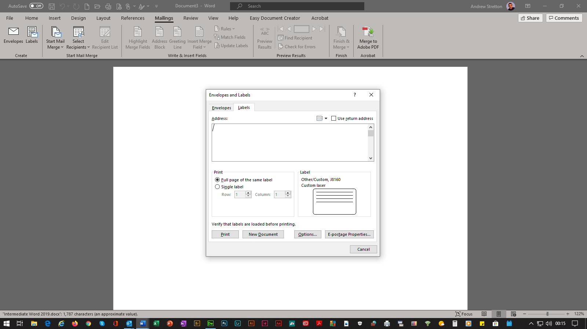
0

N.B. The Microsoft Word SQL Command: Dialog Box Link To Database Details Will Appear After Download Confirmation, Select Yes Button.

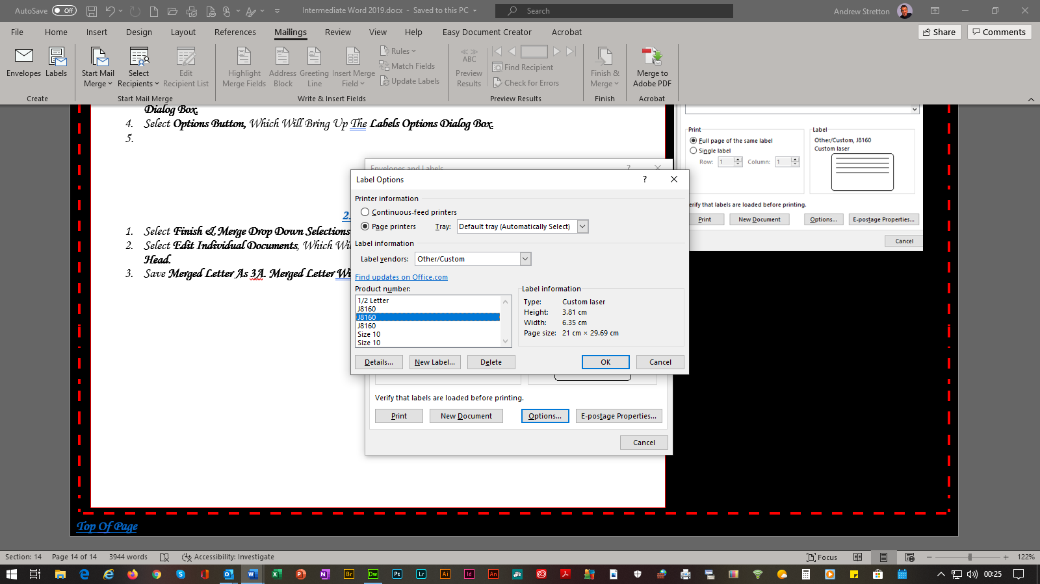

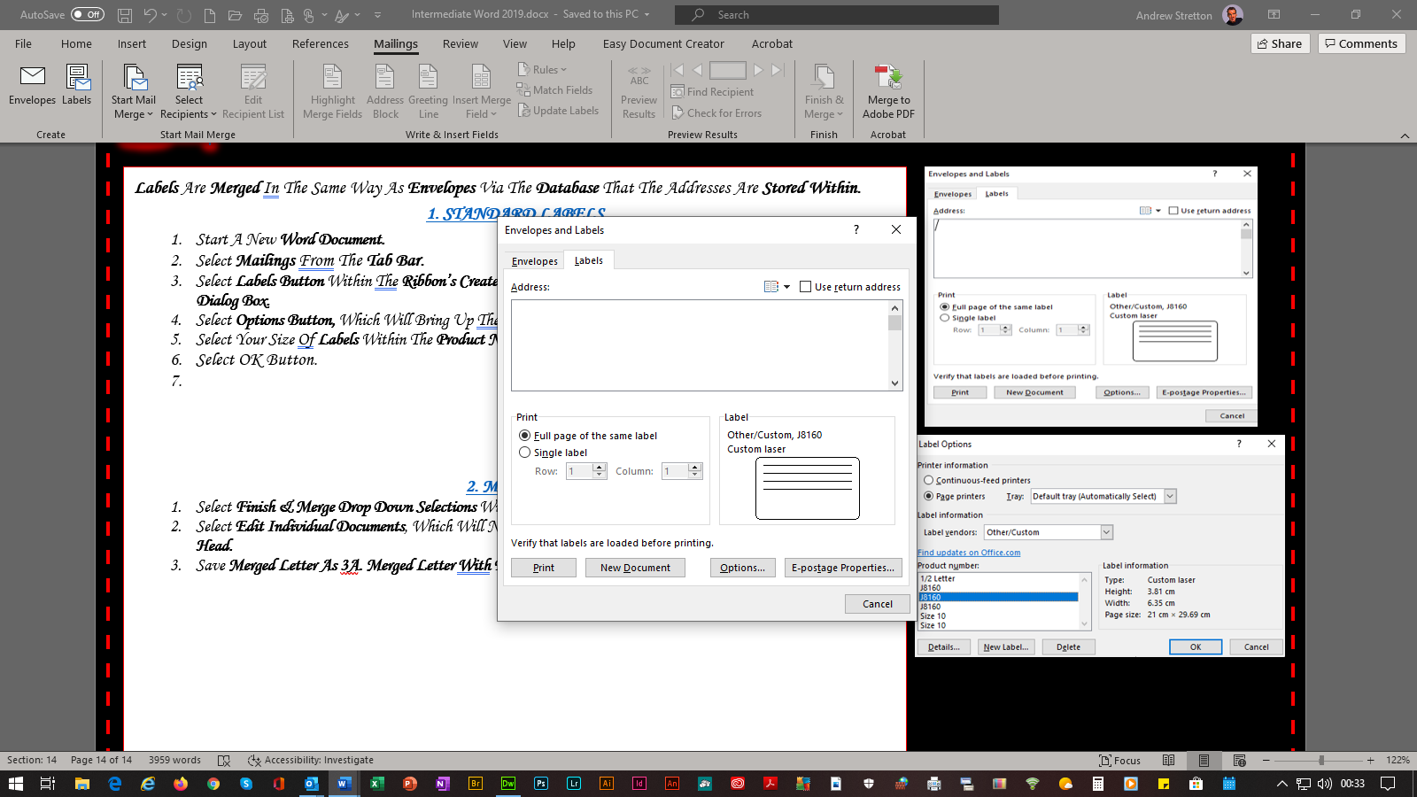

Top Of Page

5.1 Templates
Contents Page
Title Page

5. TEMPLATES & BUILDING BLOCKS

Templates Are Documents Settings And Formats Which Are Implemented At First Hand, I.E. A Company Headed Letter Would Have Details Within It That You Would Not Have To Type Again, Just Type In The Details That Need To Be Entered, As With Memorandum, Reports, Etc.

TEMPLATE SET UP

- Select File Explorer.
- Select My Documents Folder.
- Locate A Headed Letter Word Document (*.Docx)
- Double Click To Open.
- Make All Necessary Settings & Formats That Would Make Things Quicker By Not Having To Add Them Each Time The Document Is Used Again.
- Select File From The Tab Bar.
- Select Save As.
- Select Browse Button Within The Save As Section.
- Locate To Where The File Is To Be Saved.
- Name The File Within The File Name: Section
- Select Word Template (*.Dotx) Within The Save As Type: Section.
- Select Save Button.

EXAMPLES OF DESIGN TEMPLATES

- PMT Logistics Letter Head Design.1.dotx
- PMT Logistics Letter Head Design.2.dotx
- PMT Logistics Letter Head Design.3.dotx
- PMT Youth Letter Head Design.4.dotx

- Memo 1 Design.dotx
- Memo 2 Design.dotx
- Memo 3 Design.dotx
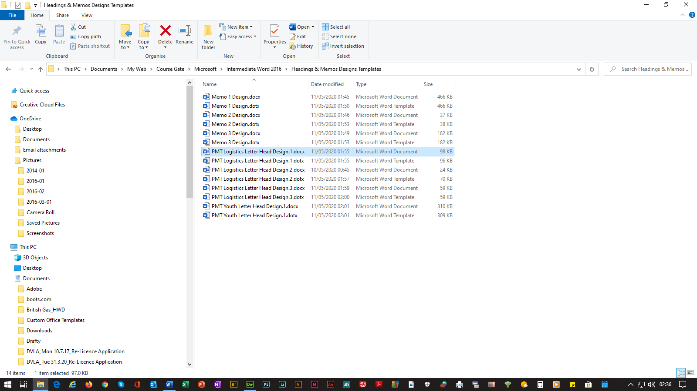

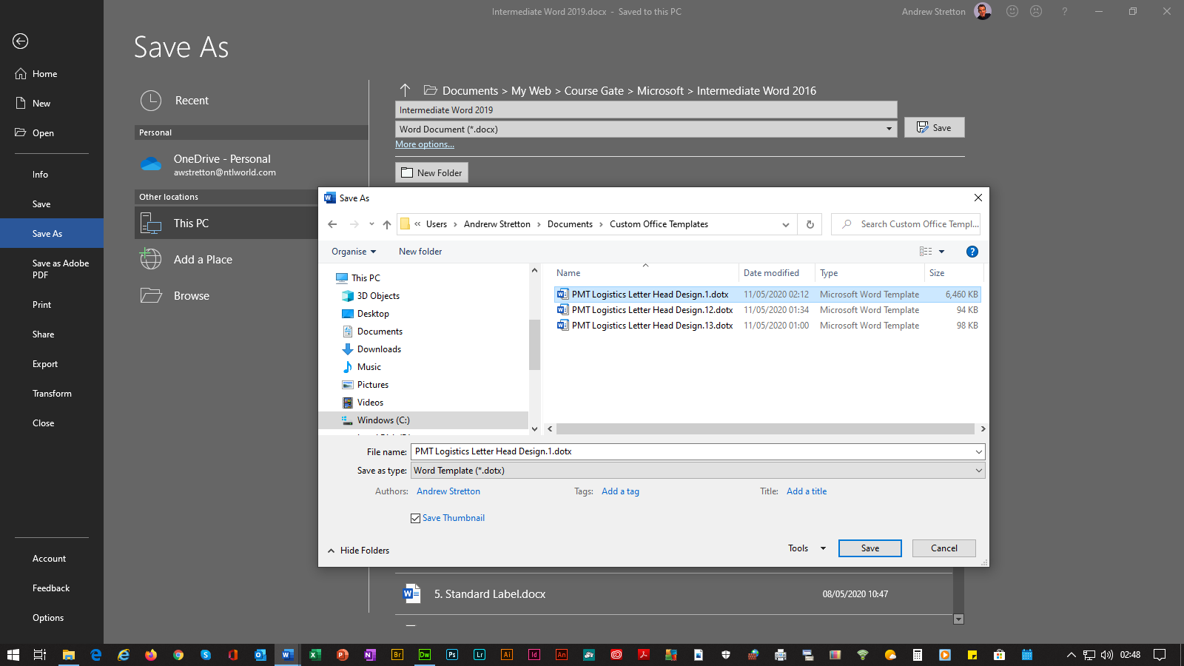

Top Of Page

Contents Page
OCR
OCR
OCR
OCR

5.2 Building Blocks
Title Page

5. TEMPLATES & BUILDING BLOCKS

Title Page

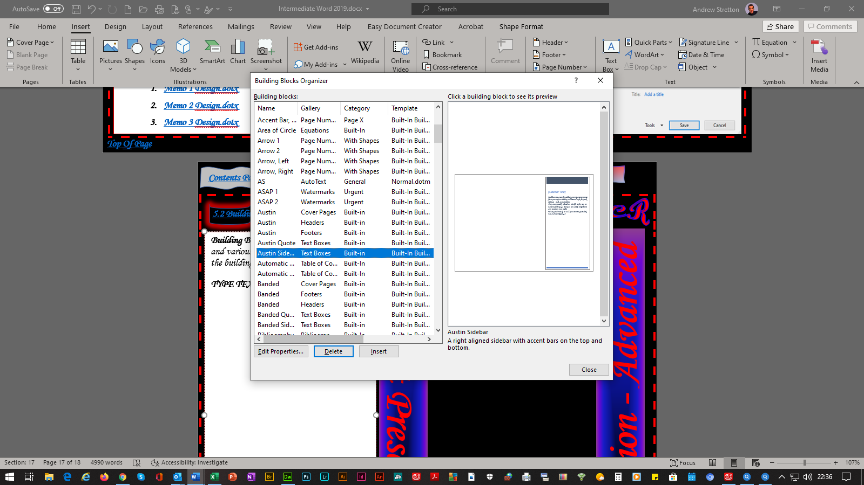
Document Presentation - Advanced
Document Presentation - Advanced
Building Blocks Allow For Various Blocks Of Text And Formats To Be Inserted Into Documents And Also Into Headers And Footers, Which Can Be Selected From The Building Blocks Organizer Gallery. They Can Also Be Edited And Saved And Used As Your Own Formatted Building Block(s) And Stored Within Your Own Category.

OWN BUILDING BLOCKS

- Select OCR Top Logo.
- Select Insert From The Tab Bar.
- Select Quick Parts Button Selections Within The Ribbon’s Text Section.
- Select Save Selection To Quick Part Gallery, Which Will Bring Up The Create New Building Block Dialog Box.
Type Document Presentation – Advanced Within The Name: Section.
- Select Text Boxes Within The Gallery: Drop Down Selections.
- Type OCR Document Presentation Advanced Examination Guide within the Description: Section.
- Select Normal.dotm within the Save In: Drop Down Selections.
- Select Insert Content Only within the Options Drop Down Selections.
- Select OK Button.
- Repeat This Procedure For The Side Heading.
- Now Both Graphics Will Be Stored Within The Building Blocks Organizer Gallery.

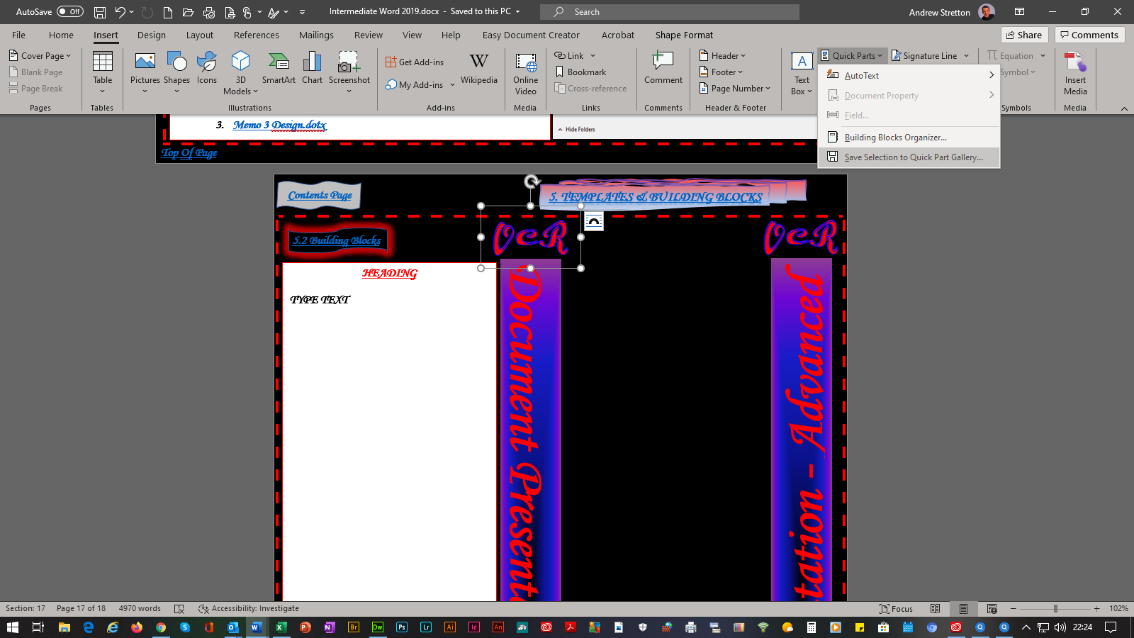

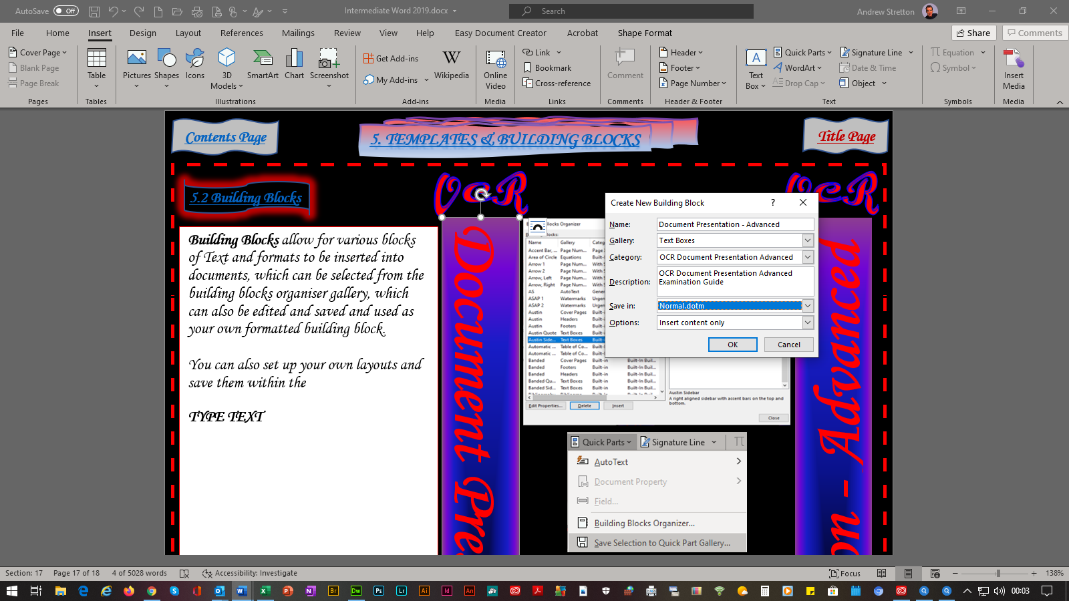

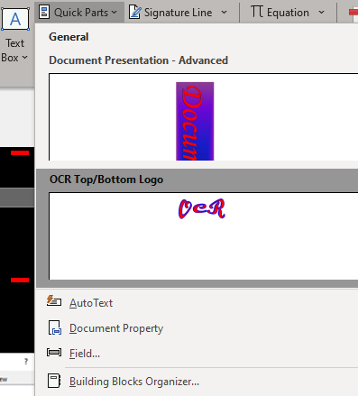

OCR
OCR
OCR
OCR

Top Of Page

Contents Page

6.1 SmartArt

6. GRAPHICS

Title Page

SmartArt Allows For Diagrammatic Layouts To Be Implemented With Whichever Layout Style They Are Referring To, I.E. What The Diagram Is Explaining Or Stating About Or Even What A List Is Detailing, Just Like An Organization Chart.

ORGANIZATIONAL CHART

- Select Insert From The Tab Bar.
- Select SmartArt Button Within The Ribbon’s Illustrations Section, Which Will Bring Up The Choose A SmartArt Graphic Dialog Box.
- Select Hierarchy Button.
- Select Organization Chart.
- Select OK Button.
- Type Manger’s Name/Position.
- Select SmartArt Design From The Tab Bar.
- Select Add Shape Button.
- Select Add Assistant Button.
- Type Assistant Manager’s Name/Position.
- Select Each Following Subordinates Typing All Salespersons’ Names/Positions.
- Select Manager’s Text Box.
- Select Add Shape Button.
- Select Add Shape Below Button.
- Type Personal Assistant’s Name/Position.
- Drag The Text Box Over & Under The Salespersons’ Text Boxes.
- Select Add Shape Button.
- Select Add Assistant Button.
- Type Administration Assistant’s Name/Position.
- Drag The Text Box Under The Personal Assistant’s Name/Position.
- Repeat This Procedure For The Second Administration Assistant’s Name/Position.

Top Of Page

Contents Page

6.2 Formatting SmartArt
Title Page

6. GRAPHICS

SmartArt Can Be Formatted By Using The Tab Bar’s SmartArt Designs Selections And Also The Format Selections. The SmartArt Designs Selections Allows You To Change Styles, Change Colors, Re-Set The Layout Back To Its Original Look, Add, Move, Change Shapes, Etc. It Also Allows You To Use The Text Pane, Which You Can Enter Text, Working Within A Bulleted List, Whichever One Of The Two Methods You Prefer To Work. The Format Selections Allows For Various Implementations, I.E. Shape Outline, Shape Fill, WordArt Styles, Etc.

ORGANIZATIONAL CHART FORMATTING

- Select The Perimeter Of The Organization Chart.
- Select SmartArt Design Within The Tab Bar.
- Select The SmartArt Styles Selections Within The Ribbon’s SmartArt Styles Section.
- Select The Brick Scene Selection.
- Select Format From The Tab Bar.
- Select The CTRL Key & Left Handle Of The Mouse.
- Click On Each Text Box.
- Select Shape Outline Selection Within The Ribbon’s Shape Styles Section.
- Select Light Blue.
- Select The Shapes Effects Button.
- Select The Glow Selection.
- Select The Orange Glow Within The Glow Variations Selections.
- Select OK Button.
- Select The CTRL Key & Left Handle Of The Mouse.
- Click On Each Text Box.
- Select Home From The Tab Bar.
- Select Purple Text Color Within The Ribbon’s Font Section.

Top Of Page

Title Page

7.1 Tracking Changes

7. MANAGING DOCUMENT REVISIONS

Contents Page


Tracking Changes Are Used For Reviewing And Amending Documents. This Process Can Also Be Carried Out By Other Users. There Are Various Markup Identification Marks Such As Bold, Italic, Underline, Color, Strikethrough, Etc Using The Advanced Track Changes Options Dialog Box, Which You Can Use To Set Your Own Tracking Markup Preferences.

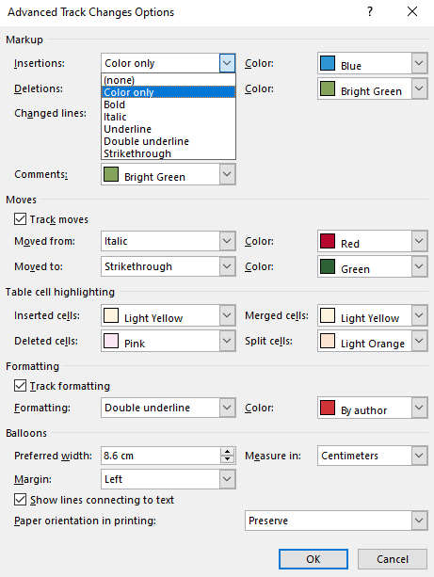

SELECT LINK FOR EXAMPLE

Top Of Page

7.2 Working With Comments
Title Page
Contents Page

7. MANAGING DOCUMENT REVISIONS

Comments Can Be Used In Conjunction With Tracking Changes, Giving A Viewer Or Other Viewers Their Views Or Asking For Changes To Be Made.

SELECT LINK FOR EXAMPLE

Top Of Page

